Quick Guide to Props

User Guide

# Contents

Introduction 1

Detailed Walkthrough 3

Elections Page 4

Ballot Measures Page 4

Measure Details Page 4

Top navigation 5

Proposition number and subject 5

Summary 5

Money raised 5

Largest contributions 7

What your Vote Means, More Information, Arguments, and Campaigns 8

Voting Information 8

Bottom Navigation 8

# 

# 

# Introduction

The Quick Guide to Props provides brief summaries, top campaign contributors, funding totals, and condensed “pro” and “con” arguments for each measure on the statewide ballot.

While the Quick Guide to Props provides quick access to important information, users looking for the full details can follow links to the wealth of information provided by the Secretary of State, down to the full text of ballot measures or a list of every contribution provided to any ballot measure committee.

The heart of the Quick Guide to Props is the Measure Details Page, illustrated below for Prop 51.

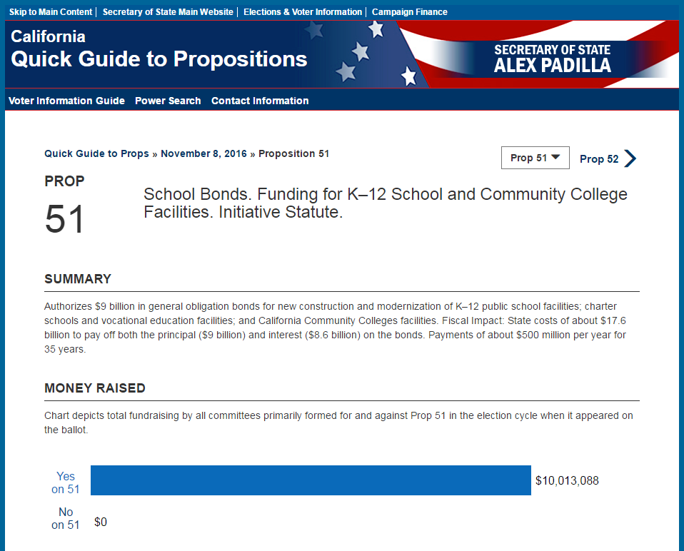

1 - Measure details page (continued on page 2)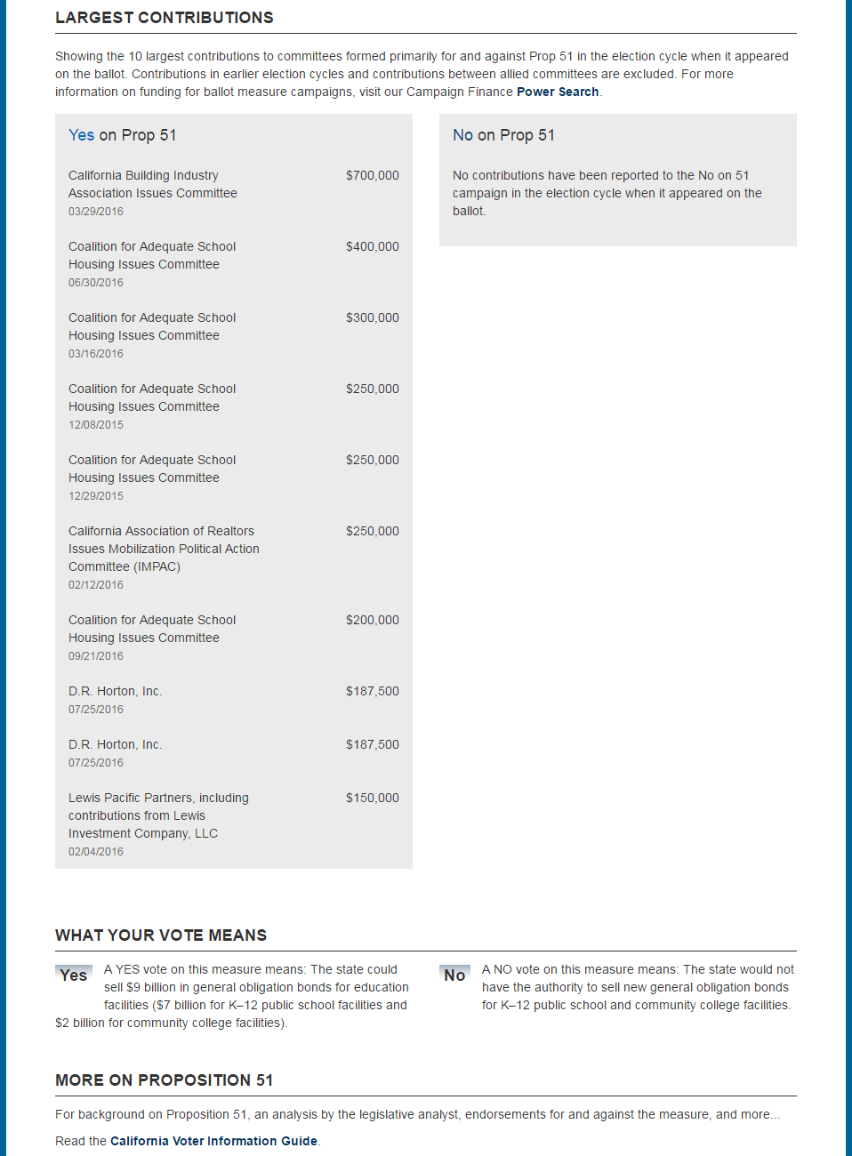

2 - Measure details page (continued on page 3)

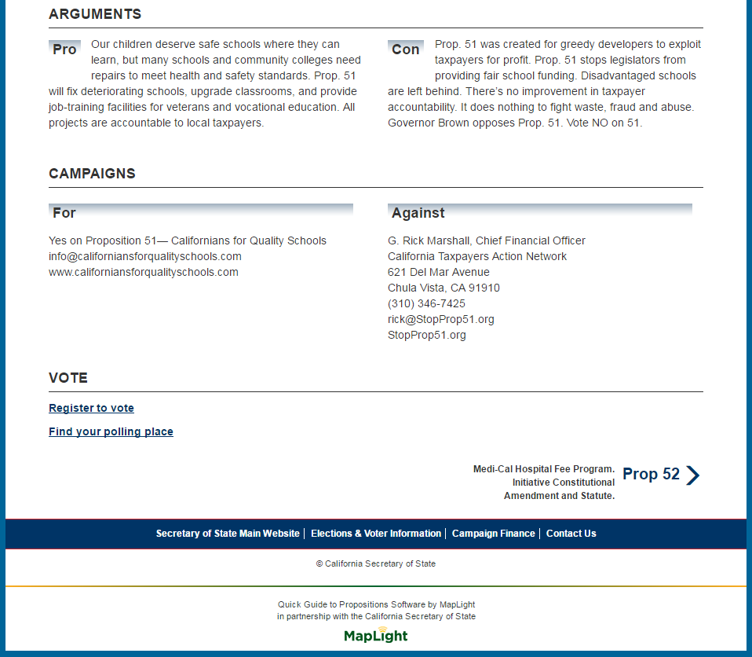

3 - Measure details page (3 of 3)

# Detailed Walkthrough

The Quick Guide to Props consists of three pages:

1. An Elections Page that allows users to choose which election to browse.
2. A Ballot Measures Page that shows users a list of each statewide proposition on the ballot for the election that has been chosen
3. A Measure Details Page that provides an easy to understand summary of each ballot measure, campaign contributions for and against the measure, brief “pro” and “con” arguments, and links to more detailed information.

## Elections Page

The elections page includes a dropdown menu with each of the elections that can be viewed in the Quick Guide to Props. The first election available in the Quick Guide to Props is the November 8, 2016 election.

The elections page can be found by clicking the “Quick Guide to Props” link in the breadcrumbs.

If there is only one election, this page automatically redirects to the Ballot Measures Page for that election.

## Ballot Measures Page

The Ballot Measures Page provides a list of all propositions that qualified for the ballot in a given election. Users can browse through the propositions by number or by subject matter and choose one to learn more about. This is an excerpt of the Ballot Measures Page:

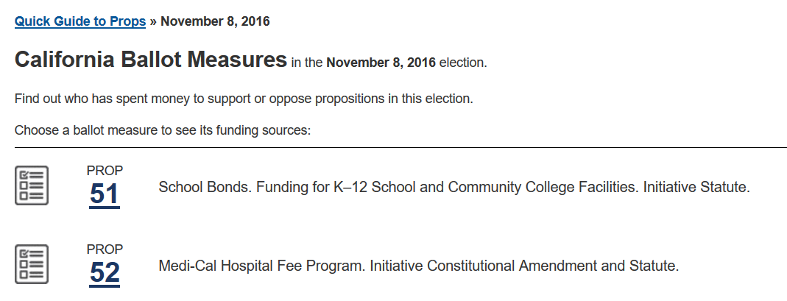

4 - Excerpt from ballot measures page for Nov. 8, 2016 election

## Measure Details Page

The Measure Details Page provides easy to understand information about a ballot measure. It has 11 sections:

1. Top navigation
2. Proposition number and subject
3. Summary
4. Money raised
5. Largest contributions
6. What your vote means
7. More information
8. Arguments
9. Campaigns
10. Voting Information
11. Bottom Navigation

### Top navigation

This section provides breadcrumbs that allow users to navigate back and choose another election, or to find other ballot measures to examine within this election.

### Proposition number and subject

This section orients the user to the proposition number and a brief introduction to the topic for the ballot measure. This section is designed to match the format of the quick reference guide index (page 3 of the November 8, 2016 CA Voter Information Guide).

### Summary

A short explanation of what the ballot measure will do. This is designed to be identical to the Summary for the ballot measure in the Quick Reference Guide section of the official CA Voter Guide.

### Money raised

Overall contributions to all committees that are primarily formed for and against the ballot measure.

#### Data Source

The numbers shown in the Money Raised graphs combine the contribution totals from Power Search, with adjustments from the most recent Political Reform Division analysis. [Power Search](http://powersearch.sos.ca.gov/) is an open-source tool that allows users to investigate state-level campaign contributions to candidates and independent expenditures from 2001 to the present.

#### Update Frequency

The portion of the page that comes from Power Search is updated daily using the bulk data from Cal-Access.

The adjustments to each ballot measure from the Political Reform Division are updated as needed. When an analysis from the Political Reform Division identifies a new correction to a committee for or against a ballot measure, the adjustment is manually applied. There is no specific schedule for when these updates are applied.

#### Methodology

The first portion - the totals from Power Search - are calculated using this logic:

1. Identify all committees that are primarily formed in support of the proposition.
2. For each of these committees, calculate the committee’s subtotal:
   1. All contributions made to these committees during the election cycle in which the proposition was on the ballot.
   2. Exclude contributions between allied committees that take the same side on the ballot measure.
3. Add the subtotals from each committee to calculate the overall total in support of the proposition.

In addition, the Political Reform Division maintains calculations for each ballot measure with adjustments to the numbers in Power Search. The Political Reform Division’s analysts can provide insight into situations that simple tabulation will miss. Some examples include:

* **Support Across Election Cycles** – Power Search bases its calculations on election cycles. Some ballot measure committees build support over more than one election cycle, however. The PRD analysis accounts for contributions in election cycles before the proposition was placed on the ballot.
* **Changes to Committee Formation** – Sometimes a committee changes its status to being primarily formed for or against a ballot measure in the middle of an election cycle. Power Search is not aware of the date for this transition. Power Search numbers will include all contributions since the beginning of the election cycle, but the PRD analysis can account for just the time after the committee’s status became primarily formed for the proposition.
* **Filing errors** – Power Search can only use the numbers it sees in the filings. If the filing itself is incorrect, Power Search will display those incorrect numbers until an amendment is filed.

[Methodology](http://www.sos.ca.gov/campaign-lobbying/cal-access-resources/measure-contributions/methodology) for the Political Reform Division analysis can be found on the Secretary of State’s website.

When combining the totals from Power Search and the Political Reform Division adjustments, rounding may cause the final result to be off by up to $1.

### Largest contributions

The 10 largest contributions to committees formed primarily for and against the proposition in the election cycle when it appeared on the ballot. Some important notes apply.

#### Data Source

The list of largest contributions is gathered from the bulk data downloads from Cal-Access. They go through additional processing by the same batch tools that populate Power Search.

From there, the Quick Guide to Props looks for 10 contributions to committees formed primarily for and against the proposition using the following logic:

#### Filter Criteria

The following contributions are excluded:

* **Contributions in earlier election cycles**

Using Cal-Access data, it would be hard to distinguish whether contributions in earlier election cycles were relevant to the ballot measure being displayed.

* **Contributions between allied committees**

This prevents contributions from being counted twice.

* **Aggregations of unitemized contributions**

These cannot be accurately considered among the “largest contributions,” since they are really collections of very small contributions. These are only shown when there are fewer than 10 itemized contributions.

* **Transactions Flagged as Errors**

It is possible for a transaction in the Cal-Access data to qualify for the list of top contributions but be flagged as erroneous. This has happened in the past with a filing using an allied committee as an intermediary for contributions. This should have been filtered out as a transfer between allied committees, but the computer analysis was not able to identify it as such.

Similar transactions, when discovered, can be manually excluded from the list of top contributions.

#### Sort Order

Remaining contributions are sorted as follows:

* **by amount** (largest first) - equal amounts are then sorted
* **by date** (oldest first), - equal amounts and dates are then sorted
* **by contributor name** (a-z).

#### Limits

Each list has a hard cutoff. Only 10 contributions will be shown, even if there is a tie for 10th place. In that case, the first contributions to be found using the Sort Order listed above will be shown.

#### Unitemized Contributions

If fewer than 10 contributions were made to all of the committees for or against a proposition after ignoring records listed in Filter Criteria, all of the unitemized contributions are shown as a single line item.

### What your Vote Means, More Information, Arguments, and Campaigns

Useful information to understand the ballot measure, copied verbatim from the Quick Reference Guide section of the CA Voter Information Guide.

### Voting Information

Links to resources allowing users to register to vote and find their polling place.

### Bottom Navigation

Allows users who to go to the next and previous propositions in the chosen election from the bottom of the page.

This section is not visible on the mobile version of the page. On mobile devices, navigation between propositions is done through the page header that is always visible.